**Bridge Manager** | **User Guide**v 1.1.8



**User Account** **1**

Logging In 1

Network Settings 1

Changing your Password 1

Account Restrictions 1

**Application Layout** **2**

Schedule & Data Panes 2

View Settings 2

**Record Management** **3**

Creating New Records 3

Editing Records 3

Linking Records 4

Deleting Records 5

Organisation & Asset Change Logs 5  
**Task Management** **6**

Creating New Tasks 6

Editing Tasks 6

Visits and Documents 7

Task Breakouts 7

**Conference Management** **8**

Creating Conferences 8

Editing Conferences 10

Cancelling Conferences 12

Deleting Conferences 12

Closure Types 12

**Recurrence Management** **13**

Creating Recurrences 13

Viewing and Managing Recurrences 13 **Resource Management**  **15**

Creating Resources 15

Editing Resources 16

Deleting Resources 16

**Using the Schedule Pane** **16**

Resource Selection 16

Navigation 17

Conference Control 17

Conference Display 18

Overlays and Readouts 19

**Using the Data Pane 20**

Layout 20

Searching 20

Conferences Search Options 21

**Data Tables** **22**

**Reports 23**

Tab Control 23

Select Query Builder 24

Select Statement 25

Query Output 27

Exporting Spreadsheets 28

Preset Management 28

BridgeManager Database Diagram 29

**User Account**

**Logging In**

When launching the application, you will be presented with the login window.

Assuming the network settings are correct, you should be able to log in with your username and password.

**Network Settings**

To connect to the agent, Bridge Manager needs to know the server IP address and network ports. Your administrator should have either set this up for you during installation or provided you with the necessary information. This information need only be set once and updated only if the network information changes.

To set or update these settings, click the Login button while holding down Ctrl-Alt-Shift. While holding the keys down, the button will change from Login to Network Settings.

A new window will be displayed. Input the information provided by your administrator and click Confirm.

**Changing Your Password**

To change your password, simply go to File > Change Password.

If you have forgotten your password and need it to be reset, you will need to contact your administrator.

**Account Restrictions**

Be aware that your administrator may have withheld some permissions from your account.

Across the application, you may notice that some buttons, tabs and fields are greyed out. If you require access to complete a task that you are unable to, you will need to contact your administrator.

**Application Layout**

**Schedule & Data Panes**

Immediately to the right of the title bar menu, you will see three buttons: **]- ][ -[**

These are used for displaying or hiding the schedule and data panes.

|  |  |  |
| --- | --- | --- |
| **]-** | **][** | **-[** |
| **Schedule Pane** | **Both Panes** | **Data Pane** |
| The schedule pane is used for displaying the conference schedule, including any potential resource overflows.  It provides the means for creating, updating and deleting conferences, as well as managing recurring bookings. | When both panes are visible, they can be resized using the divider. | The data pane is used for displaying data in table form.  It provides the means for searching, updating and deleting records, conferences, recurrences and resources.  You may also export data directly from search result tables for use in spreadsheets. |

**View Settings**

**Storing View Settings**

During logout, Bridge Manager automatically stores the following settings against your account, and restores them upon logging back in.

* Pane widths
* Last viewed conference window size

* *Excludes result tables in the SQL Query Builder   
 and SQL Statement tool.*

* Table column widths *
* Table column visibility *
* Table column order *
* Data pane configuration

Note that closing Bridge Manager with the **X**  button automatically logs you out, meaning that the view settings will still be stored. This would not be the case if you were to terminate the application through the task manager.

**Resetting View Settings**

If you wish to reset your view settings to default, go to File > Reset View Settings.

**Record Management**

The term ‘record’ in Bridge Manager is used collectively for individual organisations, assets and contacts.

**Creating New Records**

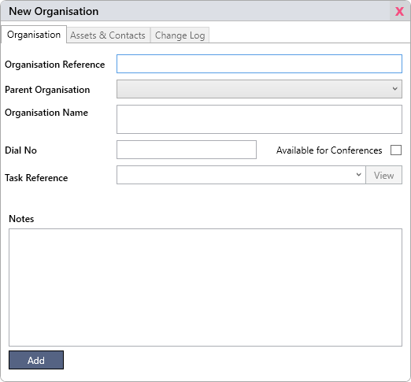In the title bar menu, go to Database > New > Organisation, Asset or Contact.

The only mandatory fields in these records are the Organisation Reference for organisations and the Asset Reference for assets. Once you have entered the desired information, click Add.

Note that you cannot link assets or contacts to organisations until after the organisation has been saved.

**Editing Records**

**Edit Single Record**

The simplest way to edit a record is to search for it in the data pane and double click on it to open it. Make any changes as desired, then click save when you are done.

**Edit Multiple Records**

To apply values to multiple records, select multiple rows in the data pane after searching. Right click on them and select Update.

Select a field from the dropdown menu and set the value as desired. If you wish to set multiple fields, click  to add more, and then  if you wish to remove them. Click Update. Note that updates cannot be undone.

Note that if an organisation’s **Dial No** is ever updated, any associated conferences will be updated with the new number. See **Adding Connections** in the **Conference Management** section for important details on this.

**Change Reasons**

When you make an edit to an organisation or assets, you will be asked to provide a reason for the change. For more information on why this is required, see the **Organisation & Asset Change Logs** section.

**Linking Records**

There are a few ways you might wish to link an asset to an organisation depending on the situation.

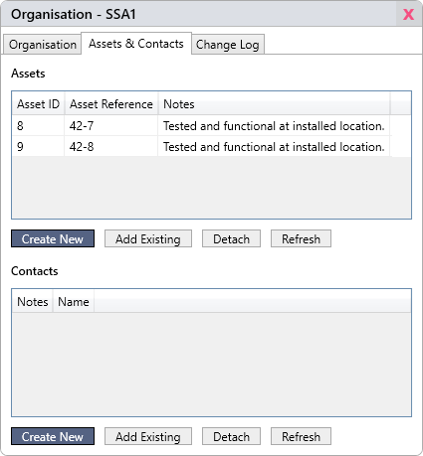**From the Organisation Window**

Open an organisation to which you wish to link one or more assets, then click on the Assets & Contacts tab.

**Create New**  
Clicking Create New will open either a New Asset or Contact window. If you’re creating an asset, its Organisation field will automatically be set to the correct reference.

Click Save once you’ve entered the desired information and it will appear in the relevant table.

**Add Existing**  
Clicking Add Existing will open a dialog window for linking one or more pre-existing assets or contacts. You can use the text field to filter the results.

Either double click the record you wish to link or select multiple and click Link.

**From the Asset Window**

To link an asset to an organisation through the asset window, simply set the Organisation field to the desired reference and click Save.

**From the Update Window**

Only assets can be linked from the Update dialog window. Select the assets you wish to link to an organisation in any data table (as described in **Edit Multiple Assets** on the previous page), then click Update. From there, set the assets’ Organisation Reference to the desired value.

**A Note on Asset Linkage**A handy feature for linked assets is that you can open their linked organisation from the asset window by clicking Open next to the Organisation field.

**A Note on Contact Linkage**While assets are linked by having their Organisation field set to an organisation’s reference, contacts function a little differently in order to allow them to be linked to multiple organisations. See the OrganisationContacts table in the **BridgeManager Database Diagram** section for an explanation of this if needed.

**Deleting Records**

To delete a record, either open it and click Delete, or right click on it in the data pane and click Delete. Record deletion can never be undone except by manually restoring from a backup, so be sure you wish to proceed.

Note that when you delete an asset or organisation, all associated entries in the change logs are deleted as well. When you delete an organisation, the dial number will be left in any conferences, but the organisation name and reference will be lost.

**Organisation & Asset Change Logs**

Organisations and assets each have associated change logs. This allows you to view snapshots of how they appeared after each change was made.

To demonstrate this, search for an existing organisation in the data pane and open it. Click on the Change Log tab.

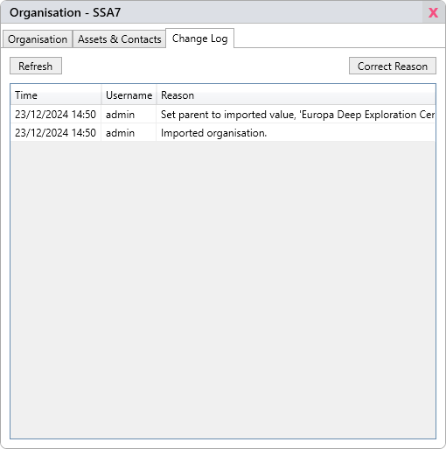The change at the bottom of the table will always represent the record’s creation. If you double click on it, a snapshot of how it looked at the time will be displayed.

The change at the top of the table will always reflect the record in its current state.

The **Username** and **Reason** columns provide the response stated at the time the edit was made, along with the user that made the edit.

It is important to always make sure that the reason given is descriptive to make perusing change logs as easy and informative as possible. They can be left blank if desired, but this is not recommended.

Note that if a user has been deleted, the Username column will read [user deleted].

**Queriability**

Note that the change tables can be queried using the Select Query Builder or Select Statement tool. This can come in useful in some cases, such as compiling a list of organisations or assets that were changed within a certain time frame, or for sorting assets or organisations by creation date.

**Task Management**

**Task References**

Much like organisations and assets, tasks in Bridge Manager are generally identified by their reference. They differ in that there is no foreign key relation in the database between the Task_Reference columns in the Task, Visit, Document or Organisation tables (as illustrated in **BridgeManager Database Diagram** at the end of this document).

This means that organisations, visits and documents can have a task reference that doesn’t exist as a task in Bridge Manager. This has the advantage of allowing you to link them to a reference external to Bridge Manager, but you must be careful to make sure that task references are updated correctly if required.

**Updating Task References**

If you wish to update a reference for a task with attached entities, always update the reference through the Task Window (see **Editing Tasks**). Upon clicking Save, you will be presented with the option to update any attached organisation, as well as any associated visits and documents.

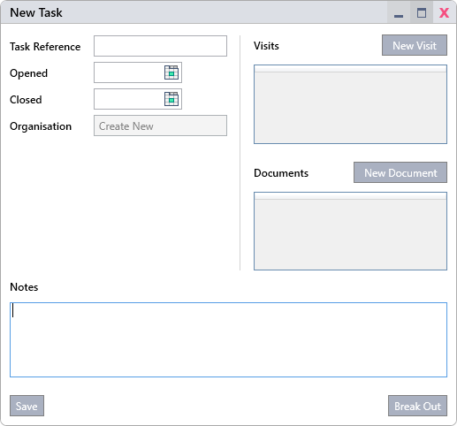**Creating New Tasks**

In the title bar menu, go to Database > New > Task. Input the desired information, then click Save.

Note that while creating a new task, you will be unable to add visits or documents, and you cannot yet create an organisation from here. Once the task is saved, these features will become available along with the Break Out function (see **Task Breakouts** later in this section.

**Editing Tasks**

To open a task for editing, either double click on it in any data table, or open it from its attached organisation’s window by clicking View next to the Task Reference field, pictured in **Creating New Records** under **Record Management**.

Once you are happy that the necessary information has been amended, click Save. Note that you do not need to save changes after adding visits, breaking out the task or creating a new organisation from the task window.

Also note that once an organisation is linked to a task, the Create New button pictured above will become a link to view the attached organisation.

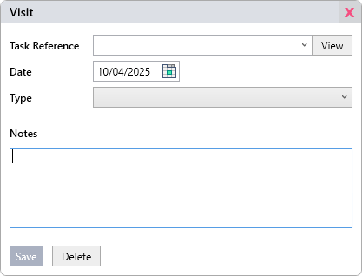**Visits and Documents**

**Visits** are intended to offer a way to track site visits, for example site surveys, installations or continued maintenance.

**Documents** offer a way to track any paperwork that may have been sent and received as part of your task management process.

**Both** are extremely similar in functionality. The Type dropdown for each can be customised by your administrator through the Settings menu, as described in the **Administration Guide**.

Vists and documents can be **created** either by going to Database > New > Task in the title bar menu, or by clicking New Visit or New Document in the Task window, depicted on the previous page

If you wish to **edit** or **delete** an existing visit or document, you can access them from the Query Select Builder, the data pane, or from their associated task.

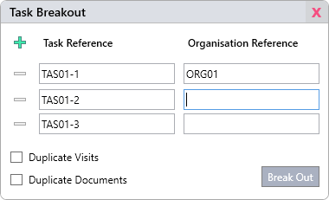**Task Breakouts**

The breakout function offers a way streamline the initial task management process in cases where one task could potentially become many, or when a task in progress needs to be duplicated along with its organisation and other attachments.

To use this feature, open a task and click Break Out. Note that if the task doesn’t yet have an organisation associated with it, the organisation fields on the right will not be displayed.

Click  to add new rows, and  to remove them.

The Duplicate Visits and Duplicate Documents check boxes allow you to select whether you wish all associated visits and documents to be replicated into each new task.

You may customise the task references and, if present, their adjacent organisation references. The original task and its associated organisation (if it has one) will have its references updated to the values stated in the first row. The same goes for any attached visits or documents.

Once you’re ready, click Break Out.

**Conference Management**

**Creating Conferences**

To create a new conference, either go to the schedule pane and double click in empty space on the grid, or go to Database > New > Conference in the title bar menu.

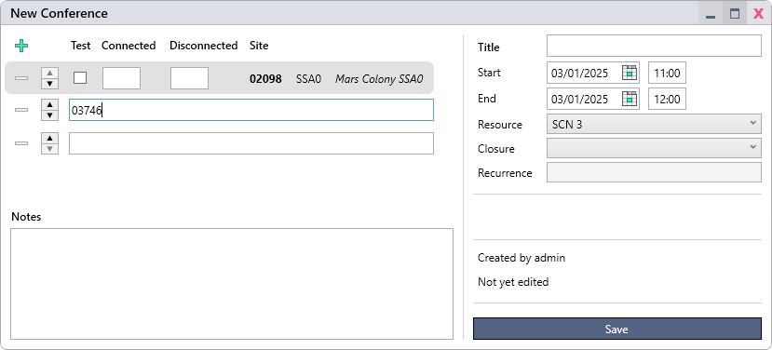

Reference the information below for explanations on each field, then click Save once all information has been set.

**Conference Field List**

|  |  |
| --- | --- |
| **Title** | *Mandatory*. The name of the conference, displayed on its block in the schedule. |
| **Start** / **End** | *Mandatory*. The booked start and end times of the conference. |
| **Resource** | *Mandatory*. The resource row on which the conference is to be placed (automatically set if created by double clicking on the schedule view). |
| **Closure** | Sets whether the conference ended successfully, was degraded, was a no-show or failed. |
| **Recurrence** | Conferences can be tied to ‘recurrences’, making dealing with recurring conferences far simpler. When set, this field becomes a button that leads to the recurrence in question. |

**Connection Field List**

|  |  |
| --- | --- |
| **Test** | Sets whether the connection is a test. If any connection in a conference has this box checked, the conference will be displayed as a test in the schedule. |
| **Connected / Disconnected** | The connection and disconnection times of the connection. |
| **Site** | *Mandatory*. The dial number, along with the organisation reference and name if the dial number corresponded to an organisation in the database at the time it was set. See **Adding Connections** for more details on this. |

**Adding Connections**

Note that this section deals with the conference window only. To learn how to add connections to multiple conferences at once, see **Adjusting Multiple Conferences** later in this section.

To add a connection to a conference, click  in the top left corner of the window. You will be presented with a text field. Input a dial number into the text field, and press enter.

If the dial number corresponds to an organisation in the database, you will see the dial number followed by the associated reference and organisation name. If it does not, then only the dial number will be displayed.

**Important Note Regarding Managed Connections and Edits to Organisations**

When updating an organisation’s dial number, any corresponding connection will also be updated *so long as the connection is ‘managed’*. Whether or not a connection is managed depends on whether the organisation was present in the database with **Available for Conferencing** enabled (a checkbox in the organisation window) at the time the connection was added to its conference.

If a connection is unmanaged but the dial number was later added to an organisation, and you need to retroactively make all corresponding connections managed, you will need to search for conferences by Dial No and manually re-enter the dial number in each conference’s connection list. This is as simple as clicking the connection’s Site field to reveal the text input and pressing enter. You will not need to re-enter the dial number or the connection and disconnection times. Save each conference once this is complete.

You can optionally force a connection to be unmanaged even if it has a corresponding organisation by holding ctrl when pressing enter, but this is not recommended.

|  |  |
| --- | --- |
| **Removing Connections** | To remove a connection from a conference, simply click  to the left of the connection row. To learn how to remove connections from multiple conferences at once, see **Adjusting Multiple Conferences** later in this section. |
| **Reordering Connections** | To change the ordering of the connections, click the ▲ or ▼ buttons to the left of the connection row to nudge them up or down. |
| **Modifying Connections** | To modify the dial number of a connection, click on the Site field. Type in the new dial number, and press enter. |

**Hosts**

The topmost connection in a connection list is considered to be the host of its conference, and is highlighted grey. This can come in useful when running SQL queries to determine billing details, for example. The host can be updated across multiple conferences – see the **Set Host** section under **Editing Conferences**.

**Clash Detection**

When working with conference bookings, you may notice that a row is highlighted red. If you hover over the red part of the row, you will receive information about where this clash is. When you attempt to save the conference, you will receive a warning, which you are free to bypass.

These warnings may also appear for resource overflows. See the **Resource Management** section for more information if needed.

**Editing Single Conferences**

To edit a single conference, simply search for it in the data pane or locate it in the schedule view, and double click on it. Make whatever changes you desire and click Save.

**Edit Multiple Conferences**

There are a few tools in Bridge Manager to carry out adjustments to multiple conferences at once.

The first and most basic is by right clicking on a selection of conferences in either the schedule or data pane and clicking Update. Use the same process as described to **Edit Multiple Records** in the **Editing Records** section.

The others, **Adjust Connections**, **Adjust Time** and **Set Host** are described below.

**Adjust Connections**

Select one or more conferences in either the schedule pane, the data pane or a recurrence window, right click on one of them, and click Adjust Connections.

**  
Add Connections**

Add connections exactly as you would in as described in **Adding Connections** under **Creating Conferences**. When you click Adjust, additions will be carried out on all selected conferences.

Any additions that would result in duplicate connections are skipped. *Example: If conferences A and B already have 2143 as a connection, then making that addition to conferences A, B and C would only add it to C.*

**Remove Connections**

Check the box in the Remove column for any connection you wish to remove from all selected conferences, and click adjust.

The **Host** column indicates whether or not the dial number is a host of any selected conference (see **Hosts** earlier on in this section). If a host dial number is removed, whichever dial number is second on any affected conference will become that conference’s new host.

The **Presence** column states how many of the selected conferences the dial number is presently in.

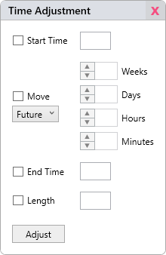**Adjust Time**

Select one or more conferences in either the schedule pane, the data pane or a recurrence window, right click on one of them, and click Adjust Time. Note that **Start Time** and **Move** cannot be used in the same adjustment, and the same with **End Time** and **Length**.

**Start Time**Set all selected conferences to have the same start time.

**Move**  
Shift all selected conferences the desired amount of time forwards or backwards.

**End Time**  
Set all selected conferences to have the same end time.

**Length**Set all selected conferences to have a uniform length.

When saving, you may be presented with a warning that the time adjustment will create a row clash. If you wish to proceed, Bridge Manager will attempt to find a free row on the conference’s resource. If the automatic row resolution fails, it will alert you and cancel the entire adjustment across all conferences, regardless of clashes.

**Set Host**

See **Hosts** under **Creating Conferences** for an explanation of what a host is in Bridge Manager.

This feature is used to shift a single connection into the top row of each selected conference’s connection list. If the connection is not present in one or more selected conferences, then those conferences will be skipped and left untouched.

Select one or more conferences in either the schedule pane, the data pane or a recurrence window, right click on one of them, and click Set Host.

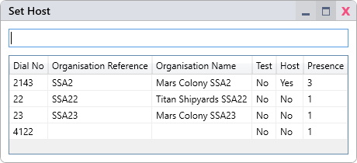Use the text box to filter connections if needed.

**Host**  
Reads ‘Yes’ if the dial number is already the host of one of the selected conferences.

**Presence**  
Displays how many of the selected conferences the dial number is currently in.

An unmanaged connection can be set as the host, but it’s advisable to steer away from this if you require the host for billing calculations or reports.

**Cancelling Conferences**

Select one or more conferences in either the schedule pane, the data pane or a recurrence window, right click on one of them, and click either Cancel or Uncancel depending on the current status of the selected conferences.

Cancelled conferences are displayed with a clear red banner in the conference window, and in pink in the schedule pane, pictured left.

Note that you can also set a conference to cancelled or uncancelled manually through the Update menu, but this is not the recommended method.

**Deleting Conferences**

Select one or more conferences in either the schedule pane, the data pane or a recurrence window, right click on one of them, and click Delete. Alternatively, select the conferences in the schedule pane and press the delete key.

Be extremely cautious with this feature, as once deleted, the conferences will be unrecoverable except by manually restoring the data from a database backup.

**Closure Types**

The Closure type can either be set using the Update menu or the window for a specific conference.

When set, this field affects how each conference is displayed in the schedule view, depicted below. Note that the **Successful**, **Degraded** and **Failed** colours are only displayed on past or in-progress conferences. See **Conference Display** under **Using the Schedule Pane** for specifics on how colours are decided.

|  |  |  |
| --- | --- | --- |
| **[blank]** |  | Until a conference has been fully written up, it makes the most sense to leave the Closure field blank to avoid confusion. |
| **Successful** |  | Used to signify a conference that ran without any serious issues. |
| **Degraded** |  | Intended to signify a conference that ran with service-related issues that caused disruption to the call. |
| **No Show** |  | Used to signify a conference where the endpoints due for connection did not show up. |
| **Failed** |  | Used to signify a conference that was unable to go ahead due to service-related issues. |

Aside from their use in visually identifying the status of conferences in the schedule pane, the Closure field can also come in handy when working with data for reporting purposes.

**Recurrence Management**

Recurrences in Bridge Manager are essentially used to group conferences together. While the usual use case will be to simplify the booking and handling of regularly occurring conferences, recurrences as a feature in Bridge Manager are intentionally flexible, allowing them to be used for general grouping of related conferences.  
  
Conferences that are a part of recurrences are indicated by a  symbol on the left of the conference block.

**Creating Recurrences**

To create a recurrence, the most convenient way is to right click on a conference in either the schedule or data pane that is not yet a part of a recurrence, and click Create Recurrence.

Enter a name for the recurrence and notes if desired, then click Save.

The conference should now have been automatically added to the new recurrence. To view it, right click on the conference and click View Recurrence, or open the conference and click on the recurrence link in the right-hand pane.  
  
If you wish to create a recurrence without adding any conferences to it immediately, you can go to Database > New > Recurrence.

**Viewing and Managing Recurrences**

There are three ways to view a recurrence:

* Locate a conference that belongs to the recurrence, right click on it and click View Recurrence.
* Search for the recurrence in the data pane by its reference or name, then double click on it.
* Open a conference and click on the link to the recurrence in the right-hand pane.

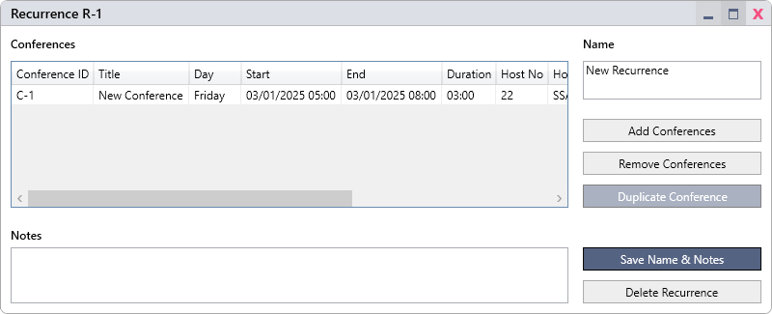

**Adding Existing Conferences to a Recurrence**

In the recurrence window, click **Add Conferences**, filter the list with the text box, select the conferences you wish to add, and click Link.

Alternatively, select one or more conferences in the schedule or data pane, and click Add to Recurrence. Filter using the text box if needed, and double click the desired recurrence.

**Removing Conferences from a Recurrence**

In the recurrence window, select the conferences you wish to remove, then click Remove Conferences.

Alternatively, select one or more conferences in the schedule or data pane, and click Remove from Recurrence.

**Creating a Run of Conferences on a Schedule**

To create duplications of a conference going forward according to a set schedule, if you do not already have a conference in mind that you wish to duplicate, create a first instance as outlined in **Creating Conferences** under **Conference Management**.

If the conference is not already part of a recurrence, add it to one or create a new one as outlined in **Creating Recurrences** earlier in this section.

In the recurrence window, select the conference. Click Duplicate.

At the top of the Duplicate Conference window, select either Weekly (pictured left), or Monthly (pictured right), depending on your needs.

The **Starting from** field should be set to the date of the second occurrence, since you’ve already created the first.

For monthly conferences, select either the date or, for example, the first Monday of each month. Note that dates are brought forward if they are impossible due to the calendar month, so that if the date is set to the 31st, it will be moved to the 28th (or the 29th, depending on the year) for the month of February.

You may choose to end on a specific date, or after a set number of occurrences.

Lastly, click Duplicate. You may receive one or more errors regarding clashes and overflows – If you choose not to proceed, the entire duplication will be cancelled.

Once the duplication is complete, the recurrence window will update. You should check the list of conferences to make sure that everything looks as it should and edit any exceptions for certain dates, such as bank holidays or weekends.

Note that duplications do not replicate dial number connection or disconnection times, leaving these blank.

**Deleting a Recurrence**

In the recurrence window, click Delete Recurrence.

Alternatively, select one or more recurrences in the data pane, and click Delete Selected.

Note that you cannot delete a recurrence with conferences still attached.

**Resource Management**

In Bridge Manager, a resource serves as a way to partition parts of the service, and also handle to conference and connection capacities. See the resource fields in **Creating Resources** for information on how they work.

Resources are displayed one below the other in the schedule pane, split out into rows according to the conference capacity.

**Creating Resources**

To create a resource, go to Database > New > Resource.

**Resource Name**Once the resource has been created, the resource name will be displayed in the schedule view with a number appended for each row. It should be descriptive of the service or infrastructure on which its associated conferences run. Two resources cannot share the same name.

**Connection Capacity**  
The number of connections that the resource can handle simultaneously.

**Conference Capacity**The number of conferences that the resource can handle simultaneously.

Note that you cannot later reduce this value if it would result in any conferences falling off the bottom of the resource.

**Additional Placement Rows**If Bridge Manager runs out of rows on which a conference can be placed in a given timeframe, it will not allow you to place any more conferences there. It may be the case that you know the resource can handle additional conferences due to some factor unknown to Bridge Manager, or perhaps you wish to make a provisional booking. In this case, you will want additional rows on which to place these exceptions when the resource is already at capacity.

Unless you know you’ll need this off the bat, it’s a good idea to leave this at 0 when creating a new resource. Additional rows can be very easily added later if you realise you need them.

Once you are happy with the configuration, click Add. See **Resource Selection** under **Using the Schedule Pane** for information on how to display the new resource.

For more information on how the application displays capacity overflows, see **Overlays and Readouts** under **Using the Schedule Pane.**

**Editing Resources**

To edit a resource, search for it in the data pane and double click on it. Make any changes as needed, then click Save. See **Creating Resources** for an explanation of each field.

Note that you cannot reduce a resource in size (the sum of the conference capacity and additional rows) beyond the lowest-placed conference.

**Deleting Resources**

To delete a resource, simply search for it in the data pane, right click on it, and then click Delete.

You cannot delete a resource that currently holds conferences.

**Using the Schedule Pane**

The schedule pane acts as a calendar view, providing detailed information on conferences at a glance. It also provides tools to manage resource capacity overflows and dial number clashes.

To view it, click **]-**  or **][**  in the title bar.

If this is your first time running the application, your schedule pane will be empty, regardless of whether any resources have already been added to the database. See **Resource Selection** below to set up your view.

**Resource Selection**

To select and set the order of the resources you wish to display, click the Select Resources button in the top right corner of the pane.

All available resources will be displayed.

Use the ▲ and ▼ buttons to set the order of the resources, and the checkboxes to enable or disable them.

Click Set when you are happy, and the schedule will automatically update to reflect your selection and order.

If there are no resources to select, see **Creating Resources** under **Resource Management**.

**Navigation  
  
Zoom**

Use the zoom buttons to zoom in and out either vertically or horizontally according to the **↕**  and **↔** symbols.

Alternatively, scroll with the mouse wheel while holding Ctrl to zoom vertically and/or Shift to zoom horizontally.

**Scroll**

There are various ways to move around the schedule:

* Hold the middle mouse button and drag to scroll horizontally and vertically.
* Use the scroll bar to scroll vertically.
* Use the mouse wheel to scroll vertically, or hold Alt while doing so to scroll horizontally.
* Right click on a conference in a recurrence window or the data pane, then click **Go To** in order to centre the schedule on that conference.
* Use one of the buttons listed below:



Scroll to a specific **date**.  
  
Reset the view to **today.**

Scroll backward or forward one **day**.  
  
Scroll backward or forward one **week**.  
  
Scroll backward or forward one **month**.

**Conference Control**

To **select** conferences, either box-select by holding the left mouse button and dragging (start in an empty space), or left click to select a single conference. Hold shift and while left clicking to add or remove conferences from your selection.

To **create** a conference, double click in empty space on the schedule.

To **open** a conference, double click on it.

**Editing Conferences**

To perform various actions on conferences such as time adjustments, setting the host or cancelling conferences (see the **Conference Management** section for information on this), right click on any conference or a conference in your selection.

To quickly **move** one or more conferences, hold the left mouse button to drag a single conference or a selection. Hold Ctrl to disable snapping to the grid. Hold Alt when clicking to **duplicate**\* instead of move.

To **resize** one or more conferences, drag the start or end of a conference. Hold Ctrl to disable snapping to the grid.

To **copy** and **paste**\* one or more conferences, use the right click menu or Ctrl-C to copy and Ctrl-V to paste. When using Ctrl-V, the paste location will be wherever the mouse is hovering on the schedule, snapped to the grid. If you are pasting multiple conferences, the paste location on the schedule is treated as the top right of the selection.

* *Duplicated and pasted conferences do not replicate dial number connection or disconnection times.*

**Conference Display**

Conferences are coloured in the schedule view for better visibility of conference states, including whether or not they have been meaningfully written up. For more information on the various conference states listed below, see **Closure Types** under **Conference Management**.

|  |  |  |
| --- | --- | --- |
| **Default** |  | The default colour is displayed for conferences before one of the states listed below overrides it. |
| **Successful** |  | Displayed when a finished or in-progress conference has been set to Successful, at least two connections have Connected and Disconnected times, and no connections have only a Connected or Disconnected time. |
| **Degraded** |  | Displayed when a finished or in-progress conference has been set to Degraded, at least two connections have Connected and Disconnected times, and no connections have only a Connected or Disconnected time. |
| **No Show** |  | Displayed when a conference has been set to No Show. |
| **Failed** |  | Displayed when a finished or in-progress conference has been set to Failed. |
| **Cancelled** |  | Displayed when a conference has been set to Cancelled. |

**Recurrence Information**

Zoom in vertically to include the recurrence name and ID in the block information.

**Status Icons**

 Part of a recurrence

▶ In progress

Icons will appear in the left-hand area of a  
conference block to indicate their status.

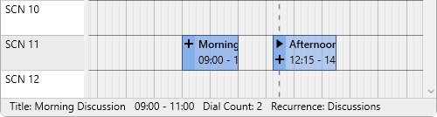**Summary**

Hovering over a conference will present you with some useful information at the bottom of the screen, pictured below. For additional options, see **Overlays and Readouts.**

**Overlays and Readouts**

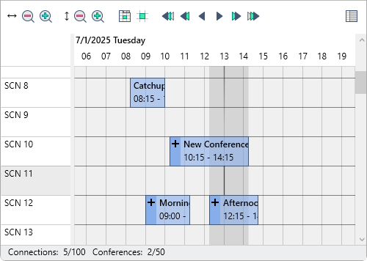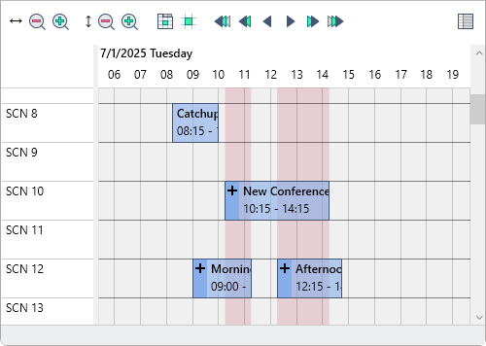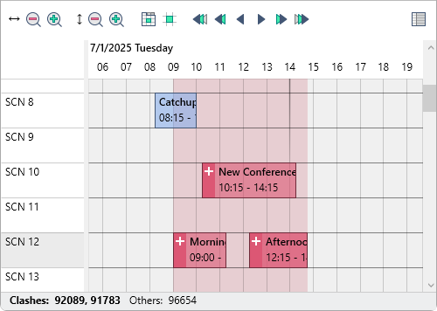**Dial Numbers & Clashes**

Holding **D** while hovering over the schedule grid will shade all conferences containing clashing dial numbers in red, and highlight the grid to indicate the earliest and latest conference start and end times where clashes are present.

When hovering over a conference while holding **D**, clashing dial numbers are listed in the status bar at the bottom of the pane, along with a list of all other non-clashing dial numbers in that conference.

**Resource Usage**

Holding **R** and hovering over the schedule grid will highlight the area between any two points where the resource usage changes.

The total resource usage and capacity for that period are displayed in the status bar at the bottom of the pane.

If either the connection or conference capacity is overflowing, they will be reported in bold.

**Resource Overflow**

Resource overflows for connection and conference capacities are reported in red regions.

Holding **R** as described above for **Resource Usage** will provide details on the overflow.

Note that if the conference capacity is overflowing, it means that the resource has Additional Rows set. See **Creating Resources** under **Resource Management** if more information about this is needed.

**Using the Data Pane**

To access the data pane, click **][**  or **-[**  in the title bar.

**Layout**

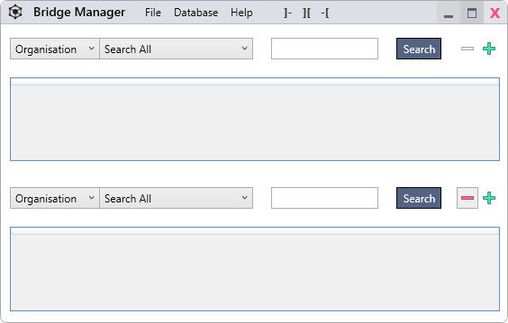The data pane can be split into up to 3 panels by using the  button, and panels can be closed by clicking  .

Panels can be resized by dragging the separator between them.

**Layout Storage**  
The number of panels and the table selection for each (Organisation, Asset, Contact, etc) are stored on logout and restored on login. Check **View Settings** under **Schedule & Data Panes** for more information on this and how to reset your view settings.

**Searching**

Select a table from the dropdown list on the left and a search type according to those listed below. To search, enter a value into the text field and click Search or press the enter key.

**Search Types**

|  |  |
| --- | --- |
| **Search All**  With this option selected, the search text field will conduct a wide search across all search columns associated with the table. To see a list of which columns the Search All function checks, select the **Search Columns** option and click the dropdown list to the right. | **Search All (historical)**  This option, only available for organisations and assets, also checks all fields in the change logs excluding the username associated with the change, the change time and the change reason. |
| **Search Columns**  With this option selected, only the columns you wish will be searched.  If you enter text into the text field, then select a different column from the dropdown list and enter text into that as well, you will notice that those two columns in the dropdown list have turned **bold**. This indicates that there is currently search text against that column, and the column will be checked when searching.  Click the Clear Fields button to clear text from all columns. | **Search Columns (historical)**  This option, only available for organisations and assets, also checks the selected fields in the change logs. |

**Conference Search Options**

The Conference search bar offers a few additional options to help narrow down and analyse results.

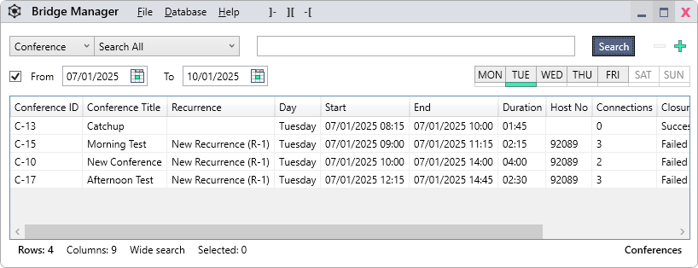

**From** / **To**



Use the From and To date pickers to set thresholds for the conference start time (the end time is not considered).

**MON** / **TUE** / **WED** / **THU** / **FRI** / **SAT** / **SUN**



The small table on the right containing the days of the week is for two things.

Firstly, you may click on days to filter certain weekdays out of your results. Click Search to update.

Secondly, after searching and bringing up at least one result, you will notice that a green indicator lights up beneath certain days. This tells you that at least one result takes place on this day. Even if you filter out certain days, these indicators will still light up to tell you if conferences would have otherwise been present in the returned results.

**Connections & Organisations**

Conferences can also be pulled up by their dial numbers and any associated organisation references and names. These columns are searched automatically when using the **Search All** option, and can be selected individually when using the **Search Columns** option.

This functionality carries over to recurrence searches, in addition to the ability to search by conference name or ID.

**Searching Conferences by Recurrence**

Searching by recurrence is not supported directly by the conference table search. If you wish to list conferences for a specific recurrence, you should search the recurrence table and then open the recurrence to view all associated conferences.

**Data Tables**

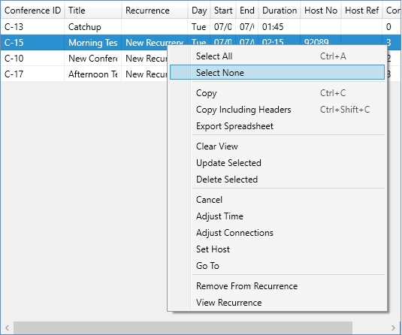  
There are some key features common to almost all tables in Bridge Manager. This includes, for example, the user account list in the settings menu (described in the **Administration Guide**) and the organisation and asset windows’ change logs.

Right click on a selection and select one of the functions listed below. Alternatively, use their specified hotkeys.

Note that there are numerous functions outside those stated below in the screenshot to the right. Many tables in Bridge Manager contain additional functions specific to that table, and occasionally omit some of the key features listed below.

|  |  |
| --- | --- |
| **General** | **Data Exporting** |
| **Select None** [Esc] Clear selection. | **Copy** [Ctrl-C] Copy the selected rows for pasting into an external program, such as a text, word or spreadsheet editor. |
| **Select All** [Ctrl-A] Select all rows. | **Copy Including Headers** [Ctrl+Shift+C]Same as above, but includes the table column headers in the copied information. |
| **Clear View** Clear results (does not delete anything). | **Export Spreadsheet** Export the selected rows to a spreadsheet in XLSX or XLSM format. Choose a location, then click Save. |

**Column View Customisation**

Columns can be **reordered** by dragging the headers, **resized** by dragging the header edges, or **hidden**/**displayed** by right clicking on any header and making your selection.

Column customisations for each individual table are stored on logout and restored on login. Check **View Settings** under **Schedule & Data Panes** for more information on this and how to reset your view settings.

**Reports**

This section deals with data extraction using the Select Query Builder tool, which also contains the Select Statement tool. This can be opened from the title bar menu by clicking Database > Select Query Builder or Select Statement.

**Select Query Builder**  
Clicking this from the title bar menu will land you in the Select Query Builder. It offers a simplified interface for querying the database for those who know the anatomy of an SQL statement, but don’t use it often enough to know the syntax by heart.

**Select Statement**  
Clicking this will open a Select Query Builder window on a code tab, rather than its default tab as described above. This tool is used for explicitly defining an SQL select statement, offering greater functionality than the Query Builder tool. It also comes with the ability to inject parameters into the code each time it is run. This enables people with no knowledge of SQL to query the database with varying parameters each time, such as a start and end date for querying the Conference table.

**Note on SQL Familiarity**

You will need to be somewhat familiar with the SQL language in order to use this feature. Specifically, some knowledge of the purposes of **join**, **where** and **order by** clauses is strongly recommended. Explaining these functions falls well outside the scope of this document, but this knowledge can be obtained easily by searching online or asking an LLM of your choice for assistance.

A complete diagram of all relevant tables used by Bridge Manager can be found at the end of this document under **BridgeManager Database Diagram**.

**Tab Control**

Tabs offer a way to organise your queries, usually with future re-use in mind. When exporting to a spreadsheet (see **Exporting Spreadsheets**), its resulting pages will reflect the tab names and order. When using the Select Statement tool to explicitly state queries, parameter values can be re-used across multiple tabs (see **Select Statement**).

|  |  |  |  |
| --- | --- | --- | --- |
|  | Add a new standard Select Query Builder tab. |  | Delete the current tab. |
|  | Add a new Select Statement tab. |  | Move the tab one space to the left. |
|  | Duplicate the current tab. |  | Move the tab one space to the right. |

**Rename Tab**

To rename a tab, simply make sure it’s selected and type a new name into the Tab Name text field.

**Reset Tabs**

Clicking Reset Tabs will reset the Select Query Builder window to contain only one blank tab, but will not change the selected preset.

**Select Query Builder**

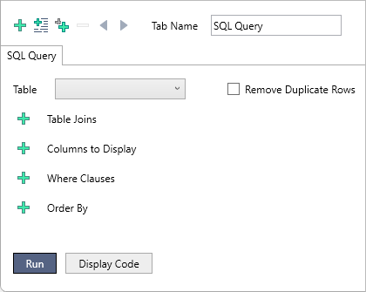Upon clicking Database > SQL Query Builder in the title bar or adding a new tab by clicking  in the top left corner of the SQL Query Builder window, you will be met with the menu pictured to the right.

This tool is not as flexible as the the Select Statement tool, but it offers enough to run moderately simple SQL queries.

The interface will be fairly self-explanatory as long as you have a rough idea of how a select statement is assembled.

Select the main table you wish to query, check Remove Duplicate Rows if required (this adds the DISTINCT keyword to the SELECT part of the query), then click the relevant  button to add the row types listed below.

To reorder rows, click the ▲ or ▼ buttons, pictured below. To remove a row, click the  button next to it. As you add and remove rows, the available columns for each dropdown list will be updated with legal values.

**Table Joins**



These rows will form the JOIN part of the statement. Check the **BridgeManager Database Diagram** at the end of this document for information on how the tables’ primary and foreign keys are linked, as this tool allows you to use any pair of columns to join the tables, which could lead to user error.

The left dropdown list in the Columns section relates to the table being joined.

**Columns to Display**



These rows form the column list of the SELECT part of the statement. The Alias text field will replace the column header in the resulting dataset, and should be left blank if you wish the column name to display as it is in the database.

**Where Clauses**



These rows form the WHERE part of the statement. Something important to note here is that empty text columns are always stored as NULL in the database, and other columns may also be NULL if a value has not been added. This has implications for the != operator, as it doesn’t work with null values. If you need to use !=, you should consider pairing it with an otherwise duplicate clause that uses the IS NOT NULL operator.

If you have multiple clauses that use both the AND and OR operators, note that these are bracketed left-associatively.

*Left-associative bracketing example: (((condition1 AND codition2) OR condition3) AND codition4)*

**Order By Clauses**



These rows form the ORDER BY part of the statement. They allow you to pre-sort the resulting dataset in either ascending or descending order. Sort priority is dictated by the order of the rows.

**Run** / **Display Code**

In order to run a query, you need at minimum to select a table and at least one column to display.

To run the query, click Run. The tool prevents most possible errors by restricting its column selections in the various dropdown lists, but some errors can still arise. If this happens, the program will relay SQL Server’s internally generated error message to back you.

The Run button will automatically populate the Query Code tab with the resolved statement, but if you wish to check the statement before running the query, or perhaps use it as a base from which to start composing a statement for the Select Statement tool, click Display Code.

The examples of rows given previously would resolve to the following code:

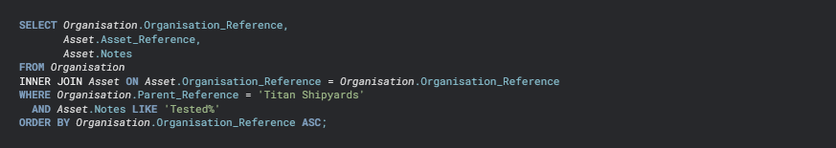

The resulting dataset is discussed under **Query** **Output** later on in this section.

**Select Statement**

The Select Statement tool offers a far more capable way to query the database, as you are free to invoke whatever querying capabilities SQL Server offers within a select statement with read-only permissions.

If you are already in the Select Query Builder window, click the button to the left to add a new code tab. Alternatively, go to Database > Select Statement in Bridge Manager’s title bar menu.

**A Note on Column Names**

An important point to note with this tool, is that you will need to use BridgeManager’s column names as they appear in the database, as opposed to any friendly names that might have been defined. Make sure to check the **BridgeManager Database Diagram** for a complete rundown of table relations and column names. If you are unsure which columns are which due to the use of friendly names, ask your administrator for assistance.

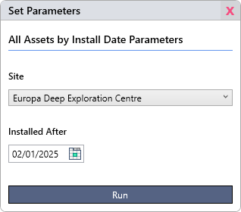**Parameters**

The Select Statement tool offers parameters as a way to vastly simplify query re-use. This is especially useful when working with other users who have no knowledge of SQL.

When a user runs a query that uses parameters, they are presented with a window requiring a value for each. When they click run, Bridge Manager automatically inserts the values for each parameter into the statement.

Below is an example of an SQL statement using Bridge Manager’s parameter implementation.

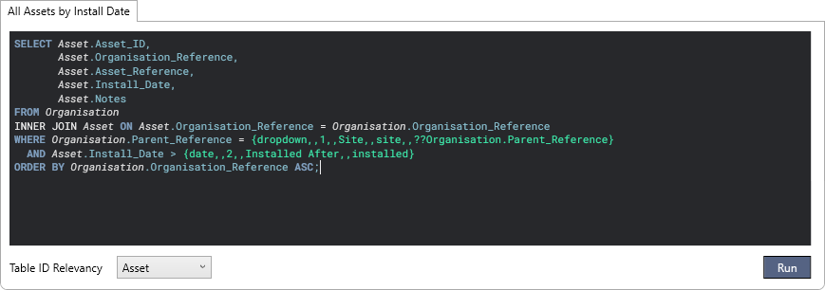

The parameters are the sections of code highlighted in green above. Below is a summary of the anatomy of a parameter, followed by an explanation of each field that makes one up. The parameter must always be enclosed in curly braces, and fields must be separated by double commas. Make sure to read the explanation for each field below to ensure correct usage.

**Parameter Anatomy**

**{**type**,,**position**,,**description**,,**optional parameter name**,,**value list**}**

**type**

The type field determines the type of data you wish to insert. Choose from one of the following values:

text dropdown checklist number datetime date time bool

Text, dropdown, checklist, datetime and date fields are automatically formatted to be enclosed in single quotes, and additionally enclosed in brackets in the case of the checklist, which will usually be intended to insert multiple values.

For dropdowns and checklists, you can either manually or automatically set their available options. For information on this, see **optional value list** below.

**position**

The position field sets the order in which the parameter will be displayed to the user in the Set Parameters window.

**description**

The text entered into this field will be presented to the user above the parameter in the Set Parameters window.

**optional parameter name**  (*may be omitted along with its preceding double comma if not required*)

You may wish to re-use the value a user enters into a parameter more than once per query. You can do this by sharing the same parameter name across multiple parameters in the statement. The first instance of a shared parameter in the SQL statement should contain all necessary fields, but every subsequent instance should instead use the following syntax, replacing “example” with the parameter name:

{,,example}

A useful feature of parameter names is that they can also be used across multiple tabs, simplifying things when running all query tabs at once or exporting the output to a spreadsheet. If you choose to use this feature, note that the full parameter definition must be replicated on each tab in the the first instance. This is because tabs can always be run individually, so the full definition must be present on each.

**value list**

This field and its preceeding double comma should be absent unless the field is either of dropdown or checklist type. The list of available options should be defined in the order in which you wish them to be displayed, separated by a double semi-colon if there are multiple. *Example:* option1;;option2;;option3. Each option should be formatted as per one of the following examples:

|  |  |  |
| --- | --- | --- |
| Some text | $$table.column | ??table.column |
| For single explicit values, simply state the desired text. | If you wish to pull a list of values from a column’s allowed values (i.e. the values that appear in the dropdown list for a column such as Conference.Closure), preceed the desired table and column name with a double dollar sign. | If you wish to pull a list of the unique values a column currently holds, preceed the desired table and column name with a double question mark. |

**Query Output**

To run your query, either click Run at the bottom of a tab to run just that tab, or Run All Tabs at the top of the window. Note that each tab holds its own dataset, so to browse the output for different tabs, flick through the tabs. Once the data is present, you can use the standard table features as described in the **Data Tables** section to extract the data, although you should also be aware of the Export All Tabs function, described under **Exporting Spreadsheets**.

**Altering or Loading Records**

Bridge Manager offers the capability to view, modify or delete records and other entities directly from the returned dataset. After following one of the procedures below, you will be able to view an entity by double clicking on its row, or update or delete one or more entities by making a selection and right clicking.

|  |  |
| --- | --- |
| **Select Query Builder** | **Select Statement** |
| Make sure that the leftmost column returned in a dataset is the ID column for an organisation, asset, contact, conference, task, visit, document, recurrence or resource. | Select the type of entity you wish to work with from the Table ID Relevancy dropdown list at the bottom of the tab, and make sure that the leftmost column in the returned dataset is an ID column for the matching type. |

**Exporting Spreadsheets**

Clicking Export All Tabs at the top of the window will generate a spreadsheet containing a separate page for each tab in the Select Query Builder window. Each page will take the name of its respective tab, so note that all tabs must have a unique name in order to use this function.

This function automatically runs all queries, so there is no need to click Run All Tabs before exporting.

All column headers are included on each page, so it’s a good idea to take advantage of column aliases to make the exported data as readable as possible.

**Preset Management**



After setting up one or more tabs for data extraction, you may wish to store them for later use. This can be extremely useful for things like running monthly reports or routinely checking for data discrepancies.

**Saving and Deleting Presets**

Clicking the Save As New button will prompt you for a preset name. Input the desired name, and click Submit. This function is also useful for making a copy of another preset to use as a starting point for a new one.  
  
Clicking the Save Changes button will do exactly that. The original preset (whichever one is named in the preset dropdown list to the left) will be overwritten by any changes you have made since loading it.   
  
Clicking the Delete Preset button will delete the currently selected preset. Deleted presets are completely irretrievable, so make sure you have the right preset selected before proceeding.

**Loading Presets**

To load a saved preset, simply select one from the Preset dropdown list.

Selecting <New> from this list is akin to clicking **Reset Tabs**, but is safer as it removes the risk of accidentally overwriting a selected preset.

**BridgeManager Database Diagram**

Note that the diagram below is not exhaustive, as it omits the OrganisationOrder, AssetOrder, ContactOrder, ConferenceOrder, TaskOrder, VisitOrder, DocumentOrder and FriendlyNames tables. Those tables are purely operational to the application and are not intended to be queried by the user or administrator.

